1. Power Spectral Density of an Image
2. Gray scale image *img04g.tif*

*Figure 1: img04g.tif*

1. Power spectral density plots for block sizes of 64 × 64, 128 × 128, and 256 × 256

*Figure 2: Power Spectral Density Plot – 64 × 64 Window Size*

*Figure 3: Power Spectral Density Plot – 128 × 128 Window Size*

*Figure 4: Power Spectral Density Plot – 256 × 256 Window Size*

1. Improved power spectral density estimate

*Figure 5: Improved Power Spectral Density Estimate*

1. Code for *BetterSpecAnal(x)* function: \*See Next Page\*

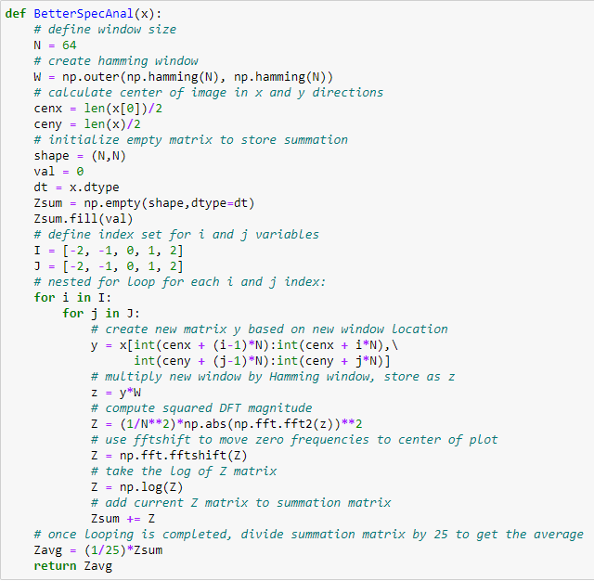

*Figure 6: Jupyter Screenshot of BetterSpecAnal(x) Function Code*

1. Power Spectral Density of a 2-D AR Process
2. Image 255 \* (x + 0.5)

*Figure 7: Scaled x Image – 255 \* (x + 0.5)*

1. Image y + 127



*Figure 8: Filtered Image – y + 127*

1. Mesh plot of the function log

*Figure 9: Mesh Plot of log $S_{y}\left(e^{jμ},e^{jν}\right)$*

1. Mesh plot of the log of the estimated power spectral density using *BetterSpecAnal(y)*

*Figure 10: Mesh Plot of log of Estimated Power Spectral Density*